Chrissie Raj Bezzam

G01465544

**1) Practice Problems: Data Manipulation and Transaction Control**

* **Create a new table containing at least four columns of four different data types (CHAR, VARCHAR2, NUMBER, DATE). Name the table your_first_name_your_last_name (substitute your_first_name with your first name and your_last_name with your last name).**
* **Insert a new record into the table created in Problem 1. When inserting a record, provide values for all columns. Use the default format for the date. Use the SELECT * FROM your_table_name; command to display the content of the table (make sure to substitute your_table_name with the actual name of your table).**
* **Insert a new record into the table created in Problem 1. When inserting a record, provide values for selected columns only. Use the default format for the date. Use the SELECT * FROM your_table_name; command to display the content of the table (make sure to substitute your_table_name with the actual name of your table).**
* **Update multiple values in the table created in Problem 1. Use the SELECT * FROM your_table_name; command to display the content of the table (make sure to substitute your_table_name with the actual name of your table).**
* **Delete one specific row from the table created in Problem 1. Use the SELECT * FROM your_table_name; command to display the content of the table (make sure to substitute your_table_name with the actual name of your table).**
* **Use the SELECT * FROM your_table_name; command to display the content of the table (make sure to substitute your_table_name with the actual name of your table). Delete one specific row from the table created in Problem 1. Use the SELECT * FROM your_table_name; command to display the content of the table (make sure to substitute your_table_name with the actual name of your table). Execute a command that undoes the deletion. Use the SELECT * FROM your_table_name; command to display the content of the table (make sure to substitute your_table_name with the actual name of your table). Note: In Oracle Live , you need to execute all the commands together as a single transaction to make ROLLBACK work. Since Oracle Live auto commits transactions, you can't rollback after a command is executed (for instance, you can't first delete a record and then use ROLLBACK to reverse the changes after DELETE was executed). To see how ROLLBACK works in Oracle Live , you need to include ROLLBACK within your transaction as suggested above.**
* **Save the changes permanently to the database.**
* **Create a script using substitution variables that allows a user to set a new value for one of the values in the table created in Problem 1 based on its PK value. Skip this problem if you use Oracle Live (it does not support substitution variables). Note: Some of the features and commands that we are learning in class might not be fully supported in Oracle Live. If you use Plus, substitution variables should work. If you use Oracle Live , either answer this question by following the studied concepts without testing it, or skip it.**
* **In the table created in Problem 1, find a column that contains numerical values and perform a meaningful arithmetic operation on data. If there is no such column, add a new column. Explain in a complete, coherent sentence what the query is intended to do.**
* **Delete the table created in Problem 1.**

**SOLUTION:**

**SCREENSHOTS:**

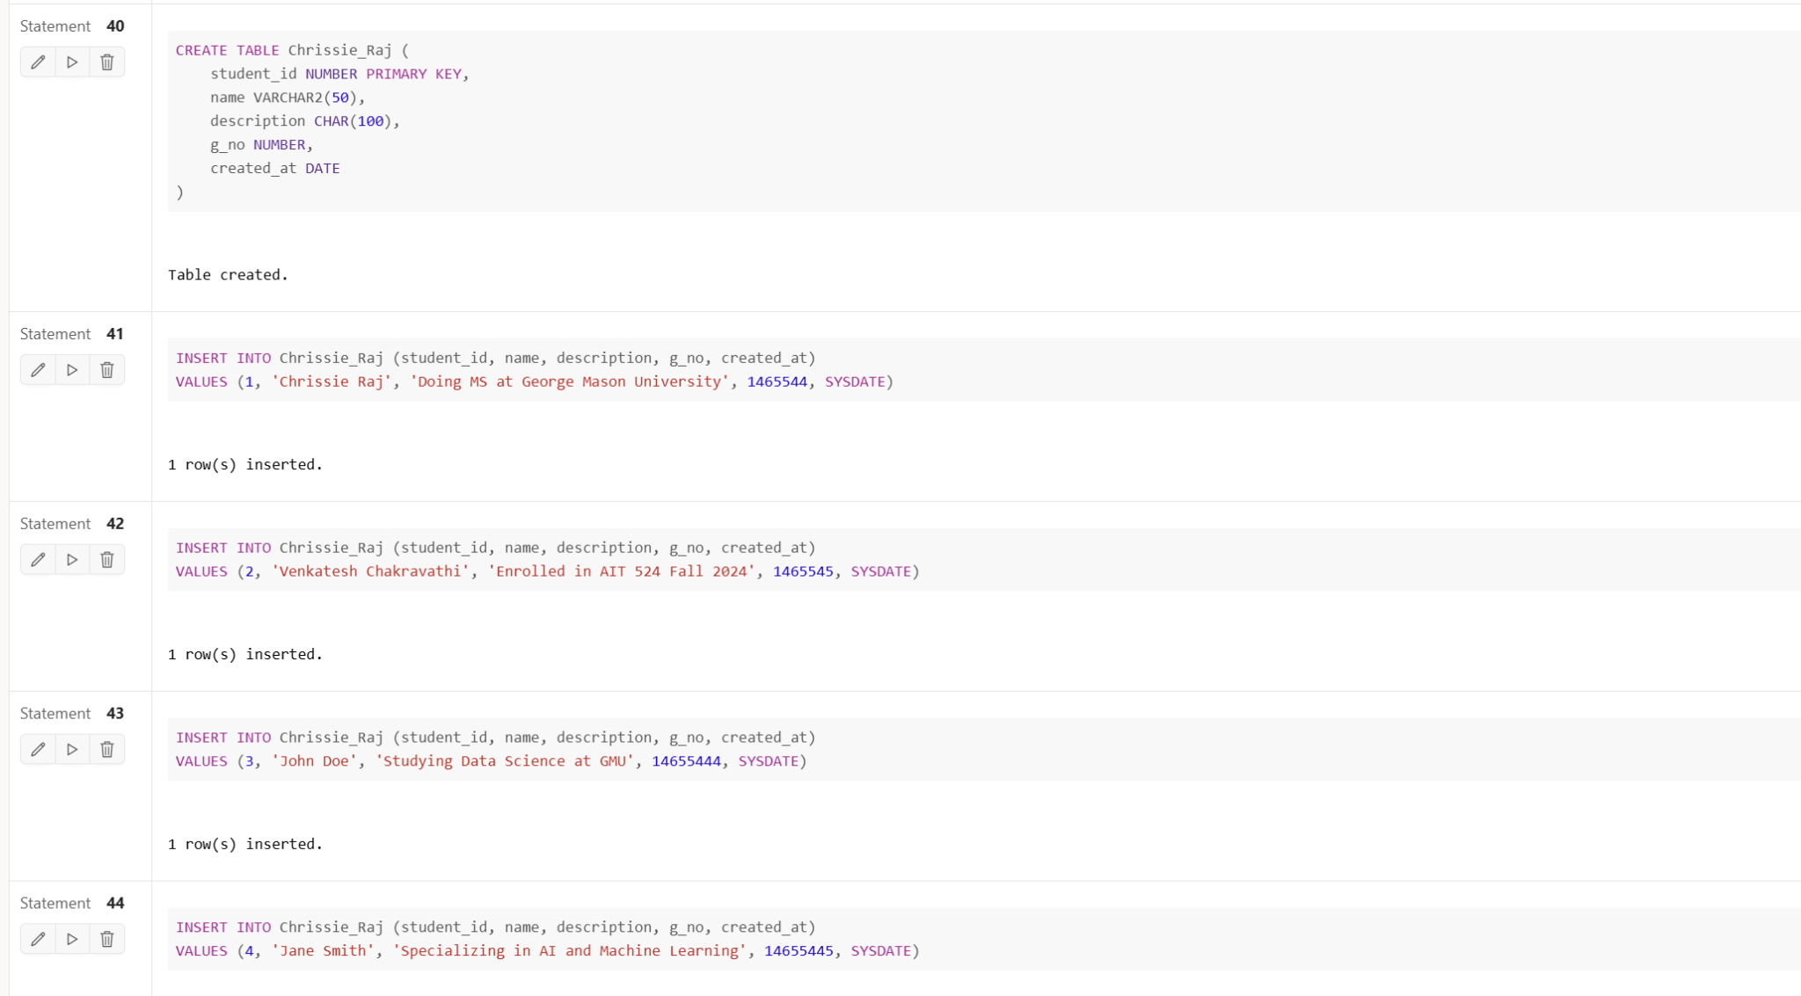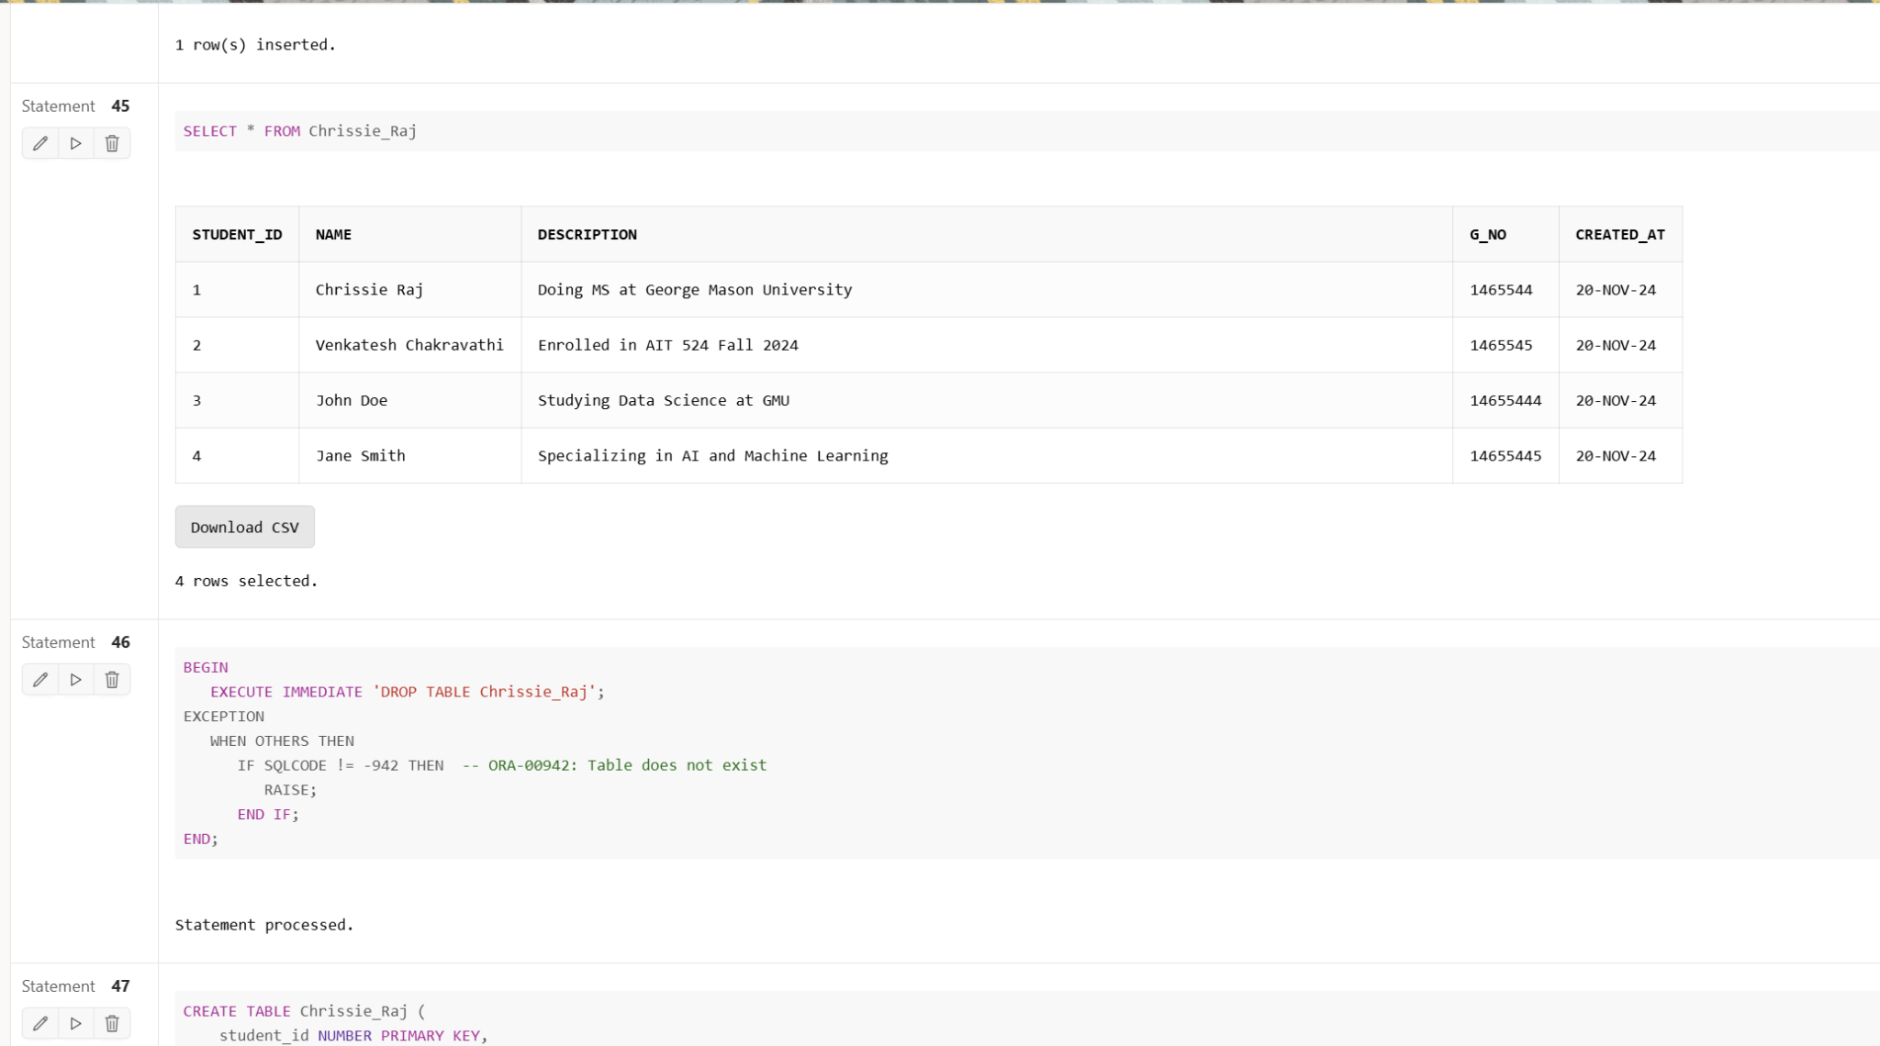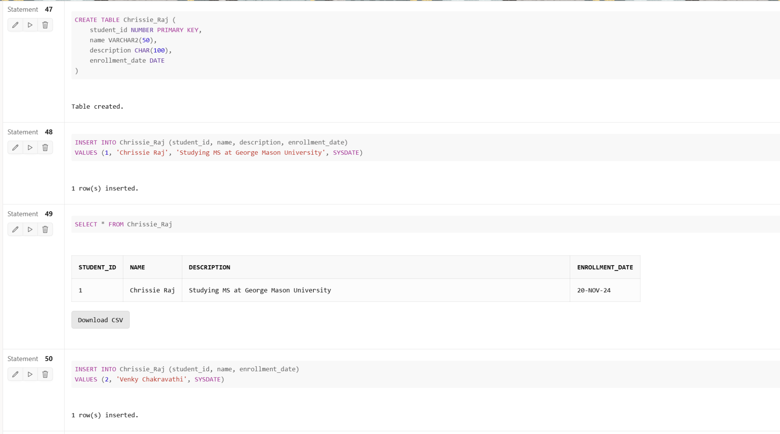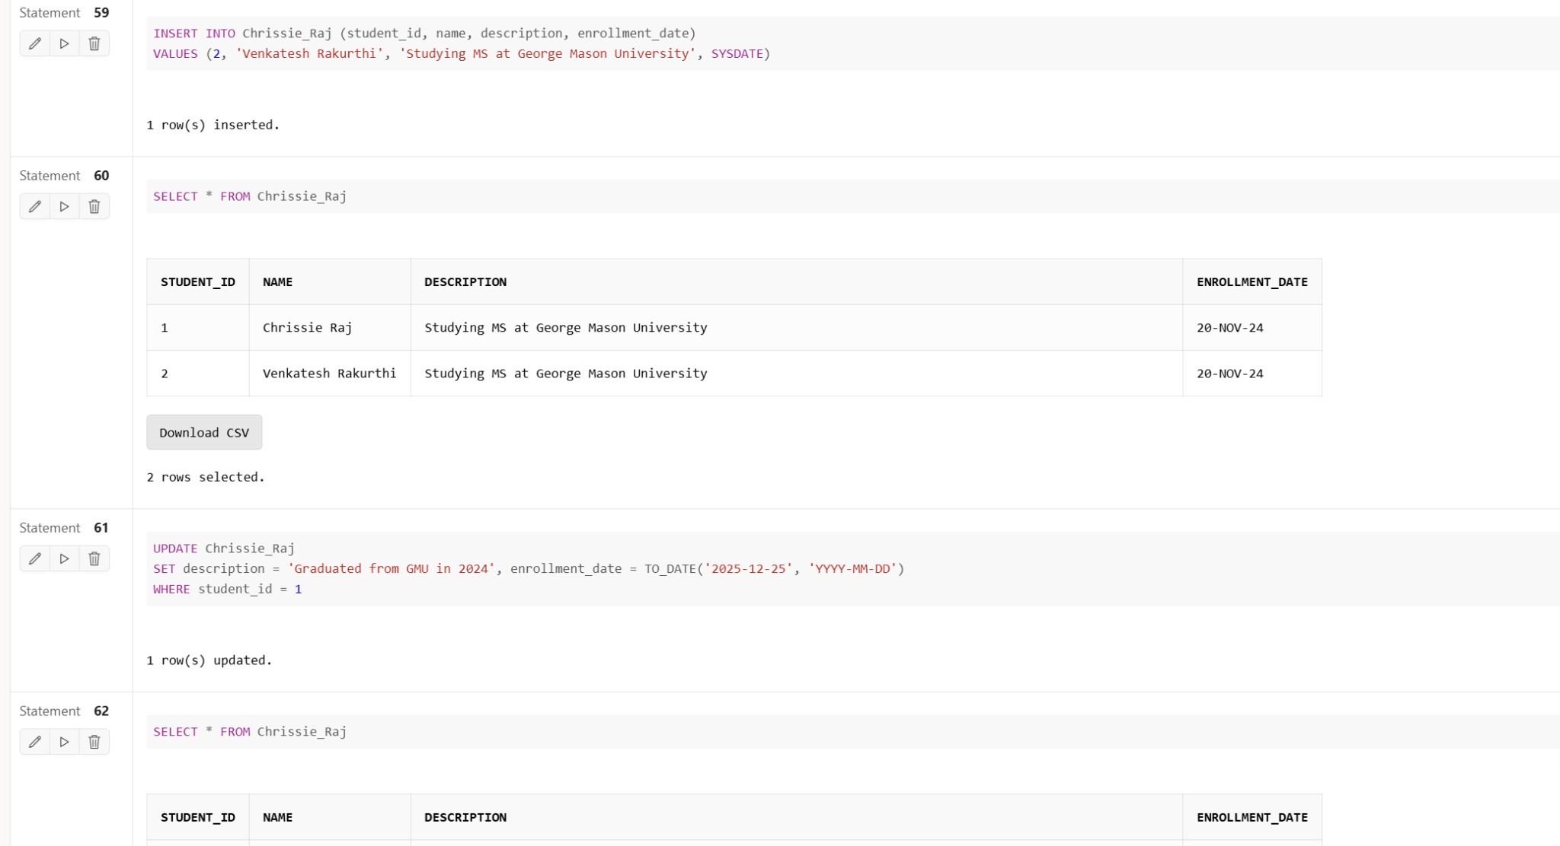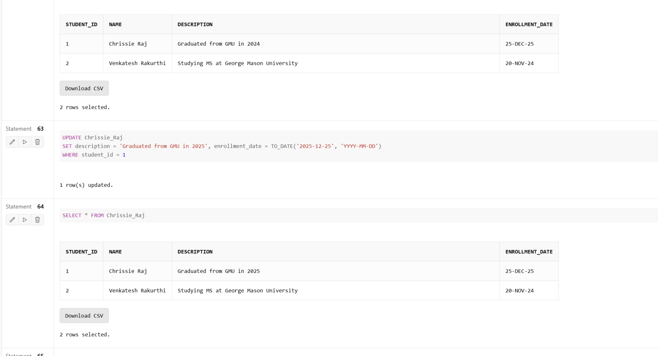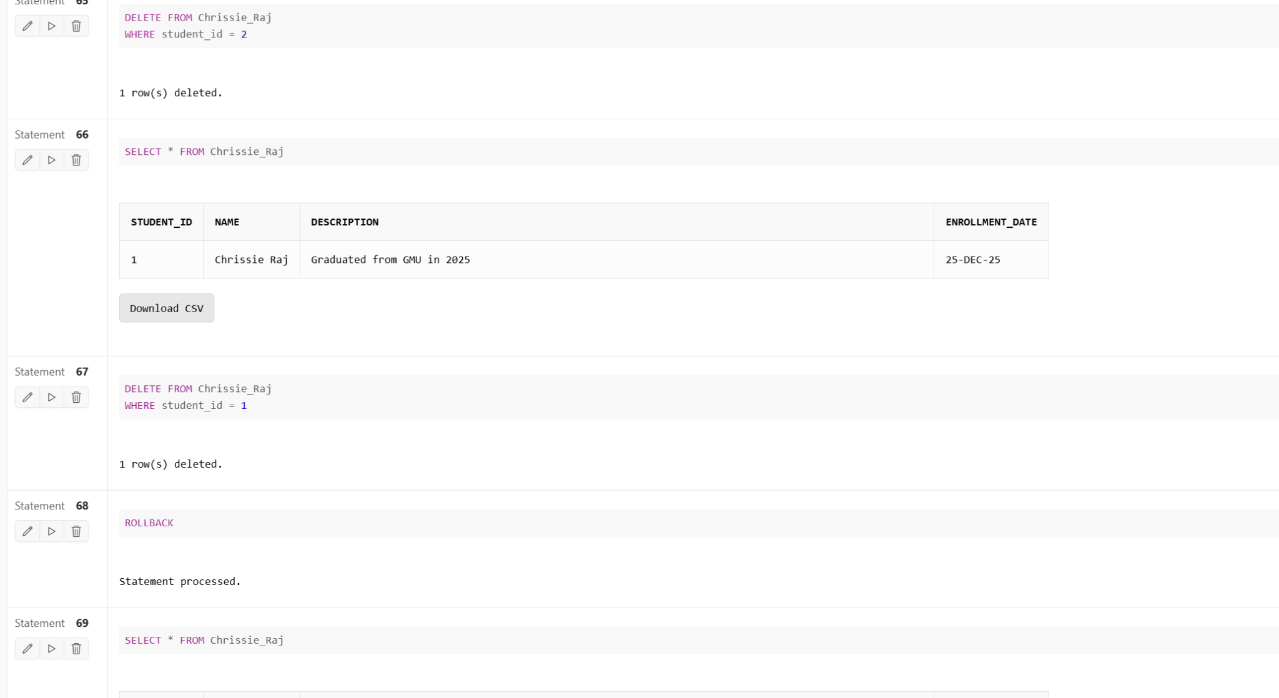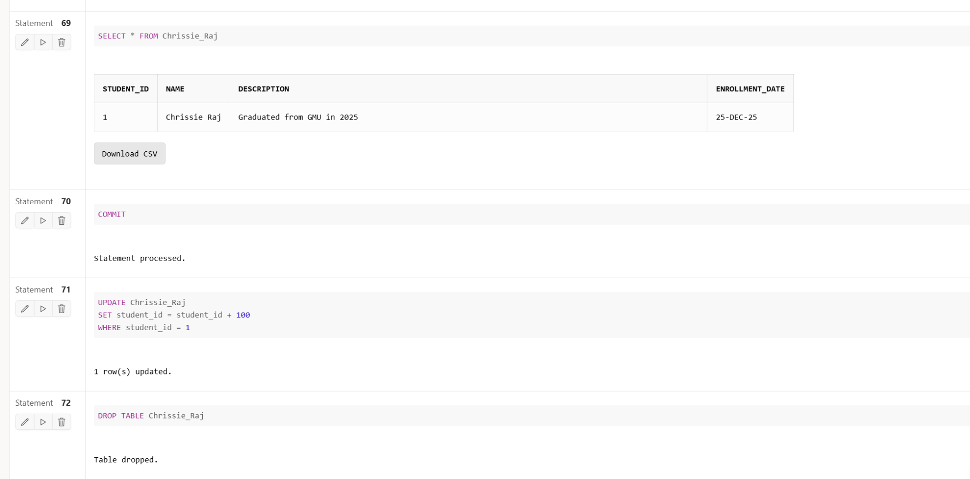

#### **1. Create a New Table**

The first problem requires creating a new table named after your first and last name, which should contain at least four columns of different data types: CHAR, VARCHAR2, NUMBER, and DATE. This task helps familiarize you with different data types available in and how to define columns using these types to store different kinds of information. Creating a table is foundational for any database work since it establishes where the data will be stored.

**Table Schema**:

CREATE TABLE Chrissie_Raj (

student_id NUMBER PRIMARY KEY,

name VARCHAR2(50),

description CHAR(100),

enrollment_date DATE

);

This schema includes a student_id (primary key), a name column for storing variable-length names, a description column for a fixed-length description, and enrollment_date to store the enrollment date of a student.

#### **2. Insert a Record with All Columns**

The next task involves inserting a record into the newly created table, providing values for all columns. This teaches how to insert data completely into each field of a table.

:

INSERT INTO Chrissie_Raj (student_id, name, description, enrollment_date)

VALUES (1, 'Chrissie Raj', 'Doing MS at George Mason University', SYSDATE);

This shows how to insert all values, including the current system date (SYSDATE) for the enrollment date.

#### **3. Insert a Record with Selected Columns**

This task involves inserting a new record by providing values for only selected columns, demonstrating flexibility in data insertion.

:

INSERT INTO Chrissie_Raj (student_id, name, enrollment_date)

VALUES (2, 'Venkatesh Rakurthi', SYSDATE);

Here, only selected fields (student_id, name, and enrollment_date) are filled, leaving others (like description) as NULL.

#### **4. Update Multiple Values**

The next step is updating multiple columns in the table, which demonstrates how to modify existing data.

:

UPDATE Chrissie_Raj

SET description = 'Graduated from GMU in 2024', enrollment_date = TO_DATE('2024-06-15', 'YYYY-MM-DD')

WHERE student_id = 1;

This command changes both the description and the enrollment_date for the record where student_id is 1.

#### **5. Delete One Specific Row**

This task involves deleting a specific row from the table. This teaches how to remove unwanted data records from a table.

:

DELETE FROM Chrissie_Raj

WHERE student_id = 2;

SELECT * FROM Chrissie_Raj;

The DELETE statement is used to remove the record where student_id is 2, and the SELECT statement is used to verify the current content of the table.

#### **6. Delete a Row and Use ROLLBACK**

This part of the assignment involves deleting a specific row and then rolling back the deletion, demonstrating transaction control in Oracle. However, Oracle Live automatically commits changes, meaning ROLLBACK can only work if all commands are executed together in a single transaction.

:

DELETE FROM Chrissie_Raj

WHERE student_id = 1;

ROLLBACK;

SELECT * FROM Chrissie_Raj;

#### **7. Save Changes Permanently**

This requires saving changes to the database permanently using the COMMIT command. It ensures that all previous changes, such as updates and deletions, are saved:

COMMIT;

This command finalizes all modifications, making them permanent in the database.

#### **8. Script with Substitution Variables**

This part asks to create a script using substitution variables to update a value in the table based on its primary key (PK). Oracle Live doesn't support substitution variables, so this problem is only applicable if using Plus.

:

UPDATE Chrissie_Raj

SET description = '&new_description'

WHERE student_id = &student_id;

This allows a user to provide a new description for a specific student_id.

#### **9. Arithmetic Operation on a Numeric Column**

This task asks for performing an arithmetic operation on a numerical column, such as incrementing a value. If there is no numerical column available, one should be added.

:

UPDATE Chrissie_Raj

SET student_id = student_id + 100

WHERE student_id = 1;

-- This query increases the `student_id` by 100 for the student with `student_id = 1`.

#### **10. Delete the Table**

Finally, the task asks to delete the table created in Problem 1. This demonstrates the ability to completely remove a table and its data from the database.

:

DROP TABLE Chrissie_Raj;

This command removes the entire table and all the data within it.

**2)Practice Problems: Restricting Rows and Sorting Data**

***Before starting these problems, update the JustLee Books database by executing the JLDB_Build_Extended.sql script. You can find the script in the "Class Databases" folder.***

* **Write an SQL query to retrieve records from one of the tables in the JustLee Books database. In a search condition, include one or more arithmetic comparison operators (=, !=, >, <, >=, etc.). Explain in a complete, coherent sentence what the query is intended to do.**
* **Write an SQL query to retrieve records from one of the tables in the JustLee Books database. In a search condition, include the BETWEEN … AND operator. Explain in a complete, coherent sentence what the query is intended to do.**
* **Write an SQL query to retrieve records from one of the tables in the JustLee Books database. In a search condition, include the IN operator. Explain in a complete, coherent sentence what the query is intended to do.**
* **Write an SQL query to retrieve records from one of the tables in the JustLee Books database. In a search condition, include the LIKE operator with either % or _ (or both). Explain in a complete, coherent sentence what the query is intended to do.**
* **Write an SQL query to retrieve records from one of the tables in the JustLee Books database. In a search condition, include the IS NULL operator. Explain in a complete, coherent sentence what the query is intended to do.**
* **Write an SQL query to retrieve records from one of the tables in the JustLee Books database. In a search condition, include multiple conditions using logical operators AND and OR. Explain in a complete, coherent sentence what the query is intended to do.**
* **Write a complex SQL query to retrieve records from one of the tables in the JustLee Books database. In a search condition, use logical operators to join multiple conditions that include at least one of the arithmetic operators and one of the special operators. Use the ORDER BY statement to order the output. Explain in a complete, coherent sentence what the query is intended to do.**
* **List the title and publish date of any computer book published in 2005. Perform the task of searching for the publish date by using one of the three methods: a) a range operator, b) a logical operator, and c) a search pattern operation.**
* **Write an SQL query to address the following scenario: A manager at JustLee Books requests a list of the titles of all books generating a profit of at least $10.00. The manager wants the results listed in descending order, based on each book’s profit.**
* **Write an SQL query to address the following scenario: A customer service representative is trying to identify all books in the Computer or Family Life category and published by Publisher 1 or Publisher 3. However, the results shouldn’t include any book selling for less than $45.00.**

**Solution:**

**SCREENSHOTS:**

1. Retrieve Records Using Arithmetic Comparison Operators

* Task: Write an SQL query to retrieve records from one of the tables in the JustLee Books database using one or more arithmetic comparison operators (e.g., =, !=, >, <, >=).
* Goal: This problem tests your ability to filter data using basic arithmetic conditions. It helps in understanding how to retrieve records that meet specific numeric criteria, such as selecting books with a certain price range.

#### **2. Retrieve Records Using the BETWEEN ... AND Operator**

* **Task**: Write an SQL query that includes the BETWEEN ... AND operator.
* **Goal**: This problem helps you understand how to retrieve records based on a range of values, such as dates or numerical values. It demonstrates how to effectively select records within a specific boundary, like books published between certain years.

#### **3. Retrieve Records Using the IN Operator**

* **Task**: Write an SQL query that includes the IN operator.
* **Goal**: This problem demonstrates how to use the IN operator to filter records based on multiple possible values. It is useful for retrieving rows that match any value from a specified list, such as finding books belonging to several categories.

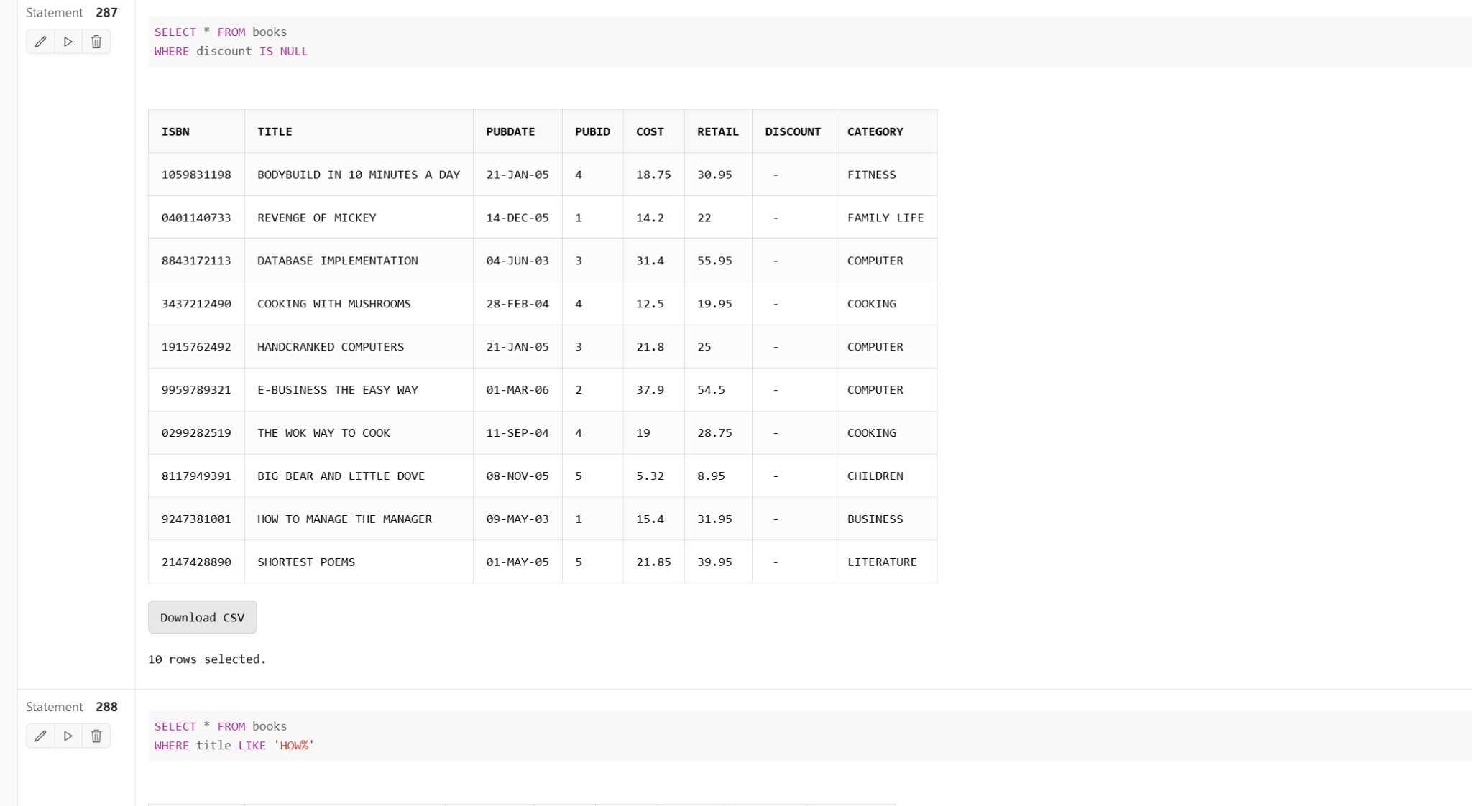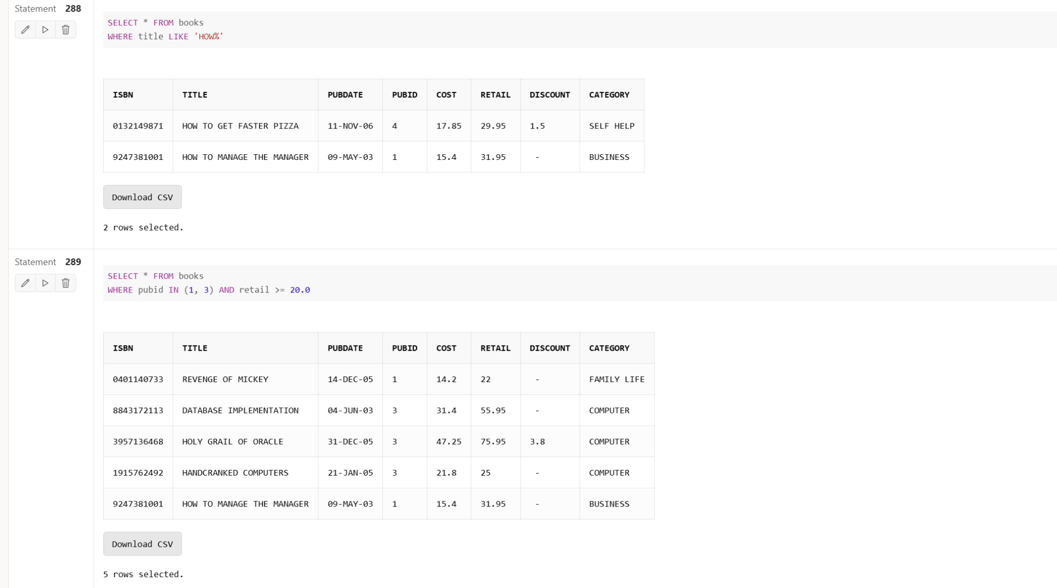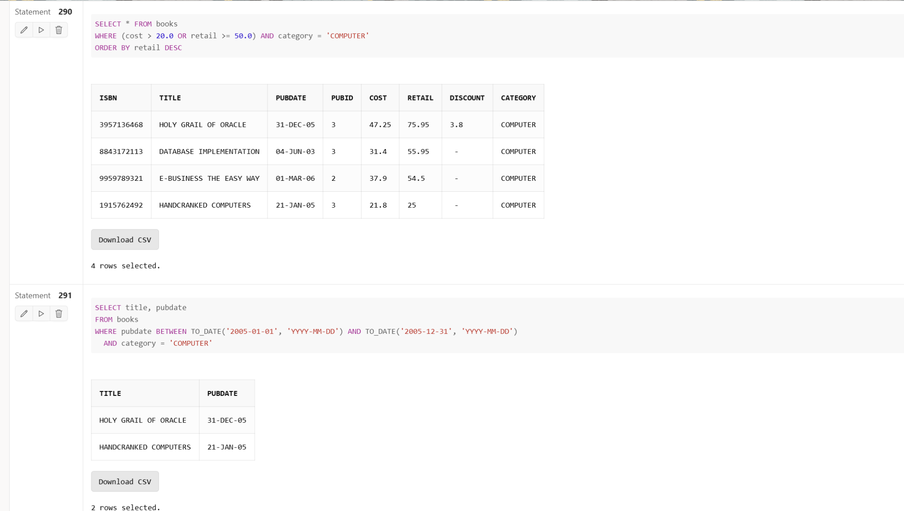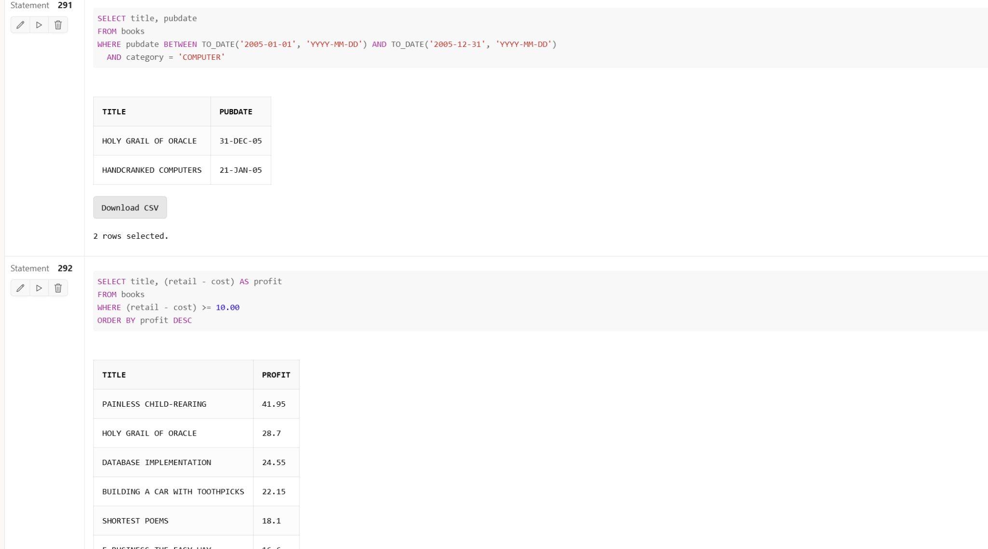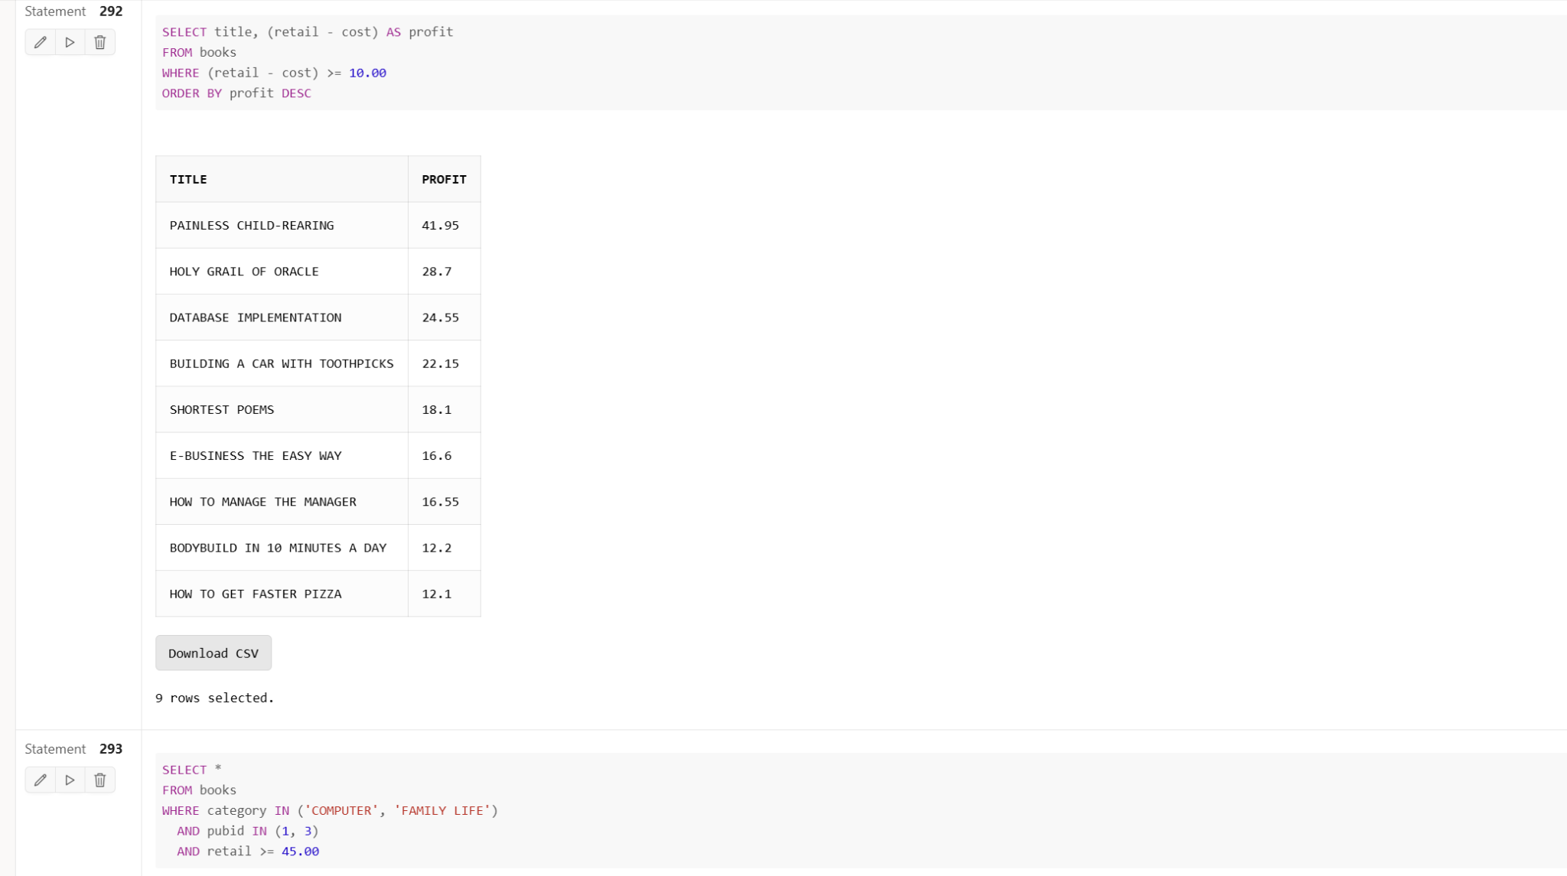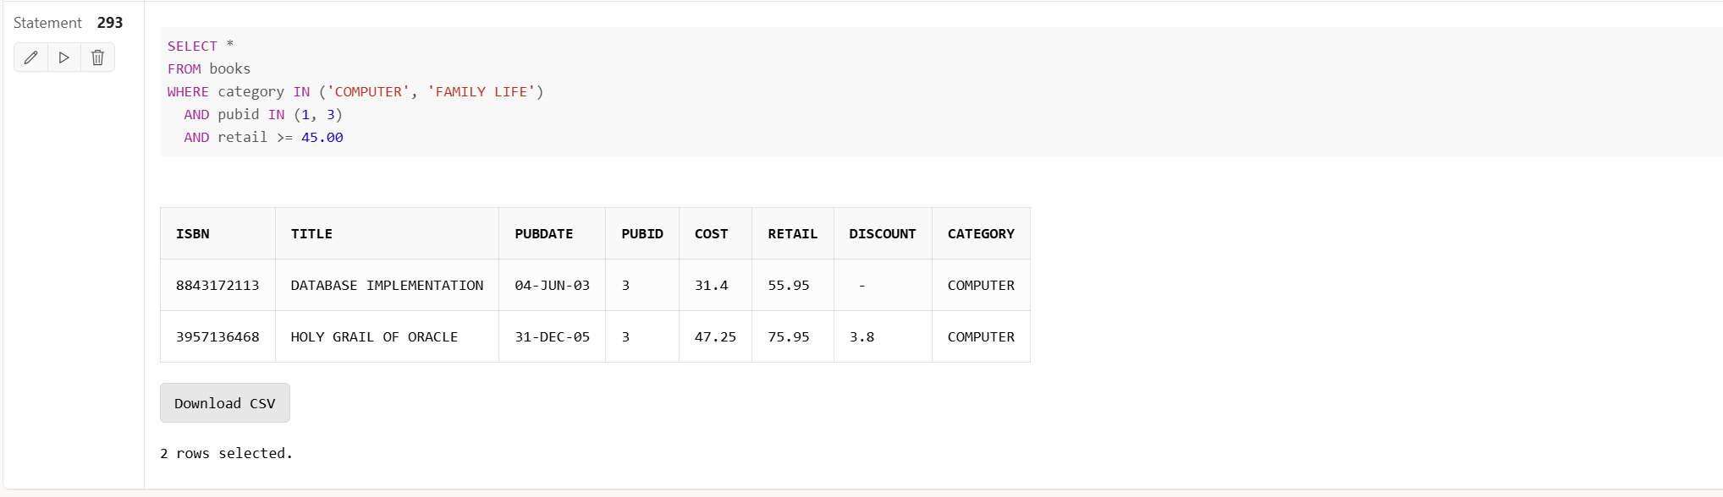

#### **4. Retrieve Records Using the LIKE Operator**

* **Task**: Write an SQL query that includes the LIKE operator with either % or _ (or both).
* **Goal**: The LIKE operator is used for pattern matching in strings. This problem helps you learn how to use wildcard characters to find records that partially match a specified pattern, such as book titles starting with a particular word.

#### **5. Retrieve Records Using the IS NULL Operator**

* **Task**: Write an SQL query that includes the IS NULL operator.
* **Goal**: This problem teaches you how to identify records that have missing or NULL values in specific columns, such as books with no discount assigned.

#### **6. Retrieve Records Using Multiple Conditions (AND and OR Logical Operators)**

* **Task**: Write an SQL query that includes multiple conditions using logical operators AND and OR.
* **Goal**: This problem focuses on combining multiple conditions to refine your query results. It helps in understanding how to create complex filters by combining different criteria, such as finding books published by specific publishers and within a certain price range.

#### **7. Write a Complex SQL Query with Multiple Conditions and ORDER BY**

* **Task**: Write a complex SQL query that uses logical operators to join multiple conditions, including at least one arithmetic operator and one special operator (BETWEEN, IN, etc.). Use the ORDER BY statement to sort the results.
* **Goal**: This problem encourages you to write more advanced SQL queries involving multiple conditions and sorting. It helps in understanding how to create complex conditions and display the results in a specific order, such as finding books with a specific cost and category, ordered by price.

#### **8. List Titles and Publish Dates of Books Published in 2005 (Computer Category)**

* **Task**: List the title and publish date of any computer book published in 2005. You can use one of the three methods: a) range operator, b) logical operator, or c) search pattern.
* **Goal**: This problem teaches how to use different operators to achieve the same result. It helps you practice different approaches for filtering records based on a date condition.

#### **9. Retrieve Titles of Books Generating a Profit of At Least $10.00**

* **Task**: Write an SQL query to list the titles of books generating a profit of at least $10.00, with results listed in descending order based on profit.
* **Goal**: This problem helps you learn to calculate derived values (e.g., profit as retail - cost) in your query and then filter based on the result. It also involves sorting the final output, which is essential for displaying business data meaningfully.

#### **10. Retrieve Books from Specific Categories and Publishers (Computer or Family Life)**

* **Task**: Write an SQL query to identify all books in the Computer or Family Life category, published by Publisher 1 or Publisher 3, but exclude any book priced below $45.00.
* **Goal**: This problem focuses on combining multiple filtering criteria, involving both logical (AND/OR) and arithmetic operators. It helps in understanding how to refine the search to match multiple conditions simultaneously.